**Dr Catherine Strassel**

**UMR_S1255**

Etablissement Français du Sang-Alsace

10 rue Spielmann-B.P.36

F-67065 STRASBOURG

Tél: 33 (0)3.88.21.25.25

Fax: 33 (0)3.88.21.25.21

e-mail: [catherine.strassel@efs.sante.fr](mailto:catherine.strassel@efs.sante.fr)

Strasbourg June 12, 2024

**Subject : Advancing Platelet Production Through Innovative Technology**

Dear Editor :

Please, find enclosed a manuscript entitled “Uniform impact on individual megakaryocytes is essential for efficient *in vitro* platelet production” by Andrei Garzon, Anaïs Pongérard, Léa Mallo, Anita Eckly, François Lanza, Olivier Boiron, Yannick Knapp and Catherine Strassel.

Our study presents an innovative research that enables optimal platelet production from human hematopoietic progenitors.

We are demonstrating a novel approach that combines turbulence and controlled flow patterns to significantly increase platelet yield.

Briefly, our platelet production device is based on a Taylor-Couette reactor. In this ingenious system, cultured megakaryocytes are confined and sheared between concentric cylinders. By carefully choosing the internal rotation regime of the cylinders - a mixture of turbulence and periodic roller-like patterns – (figure : Taylor Couette System at Glance)

we were able to show:

**1. Increased platelet yield**: our system produced a significant number of platelets, among the highest yields in the literature (79±19 platelets in vitro per megakaryocyte), with native-type morphology and functional properties, which forms the basis of platelet production for medical purposes.

**2. Optimized flow effects**: unlike traditional turbulent conditions, we generate a “uniform impact” of flow on each megakaryocyte, a never-before-described condition that has proved essential for efficient platelet release. This discovery challenges existing paradigms and underlines the need for customized bioreactor design.

**3. System scalability**: The system has demonstrated its ability to adapt to large volumes without compromising either platelet release efficiency or functionality. This scalability is a game-changer when it comes to adapting platelet production systems to large-scale production, which is currently problematic. Our system can therefore be easily adapted to industrial-scale platelet production, without having to modify any parameters.

In conclusion, this platelet production system represents a significant advance in the field of culture platelet production for medical purposes. Its precision and predictability hold great promise for use in the widest possible range of applications. We trust that these findings will be of interest to the PNAS readership.

Sincerely yours,

Catherine Strassel

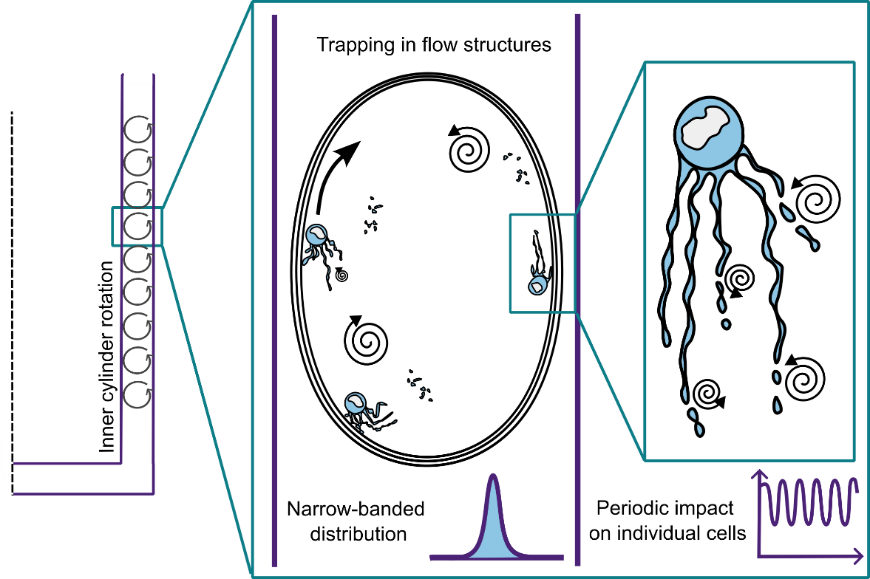

Figure: Taylor Couette System at Glance